Fisheries Conflict Analysis
Tanira Chau and Madeline Wheeler
Sponsor: World Wildlife Fund
Practicum Summer 2026
Group 9

Introduction
Illegal fishing and fisheries conflicts threaten marine ecosystems, food security, and coastal livelihoods worldwide. To better understand the factors that contribute to fisheries conflict, the World Wildlife Fund (WWF) sought to improve its existing predictive modeling efforts using a global event-level dataset.
Our approach to this project had two primary objectives:
- Predict the likelihood of fisheries conflict severity using event-level socioeconomic, governance, fisheries, and environmental variables.
- Identify the most relevant predictors associated with fisheries conflict by evaluating feature importance across multiple machine learning models.
NOAA monthly sea surface temperature and el nino southern oscillation data were integrated with the WWF fisheries conflict event dataset to create an enriched analytical dataset. Logistic Regression and Random Forest models were then developed and evaluated.
The resulting models provide both predictive capability and interpretability, supporting WWF in their mission to better understand which factors are most strongly associated with fisheries conflict and inform future monitoring, risk assessment, and resource management efforts.

Data
WWF provided an event-level dataset of 1,058 fisheries conflicts that occurred between the years 1990 and 2024. The variables included in the models include region, WeakGov, FishPop, EcoChngeOther, GroundsLim, ForeignFisher, IllegalFishing, IncrEfficiency, OpsScales, Markets, Poverty, FoodInsecurity, Marginalization, StratLoc, and MaritimeCrime. Descriptors of each of these variables is provided at this link then clicking the text “Colleen Devlin, Sarah M Glaser, Joshua E Lambert & Ciera Villegas: The causes and consequences of fisheries conflict around the Horn of Africa.” The response used was the violence_score which had values 1, 2, or 3. A violence_score of 1 denotes low-level intensity conflict that is verbal with no physical action taken. A violence_score of 2 denotes mid-level intensity conflict where action was taken but no physical harm was done. A violence_score of 3 denotes high-level intensity conflict involving physical harm.

Integrating NOAA Sea Surface Temperature Data
Fisheries productivity and species distributions are often influenced by deviations from normal ocean conditions rather than absolute temperature alone. For this reason, monthly sea surface temperature (SST) observations from the National Oceanic and Atmospheric Administration (NOAA) Extended Reconstructed Sea Surface Temperature Version 5 (ERSSTv5) dataset were incorporated as an additional predictor variable. These values were joined using the date and geographic coordinates for each fisheries conflict event.
A reusable data integration pipeline was developed to automatically retrieve the NOAA dataset, spatially match each fisheries conflict event to the nearest ocean grid cell, and append the corresponding SST measurement to the WWF dataset. The matching algorithm first converted event dates to monthly timestamps to match NOAA's monthly observations. Longitude values were also converted from the WWF convention (-180° to 180°) to NOAA's coordinate system (0°–360°).
Each event was initially matched to the nearest SST grid cell at the same latitude and longitude. When WWF events occurred inland or near coastlines where SST observations are unavailable, the algorithm progressively expanded its search radius until a valid ocean pixel was identified. For each successful match, additional metadata were recorded, which includes the matched SST latitude, longitude, search radius, and great-circle (Haversine) distance between the reported event location and the matched ocean pixel. These metadata provide transparency regarding the spatial uncertainty associated with each SST measurement.
Following the spatial matching process, only three observations remained unmatched because no valid ocean pixel could be located within the maximum search radius. These observations were excluded from subsequent analyses since no SST value could be assigned.
Observations with matched SST grid cells located more than 300 km from the reported event coordinates were removed and the data due to temperatures between the two locations possibly differing greatly. Removing these observations reduced model performance and substantially decreased the predictive importance of the SST variable. This decrease in data due to spatial uncertainty is a limitation.
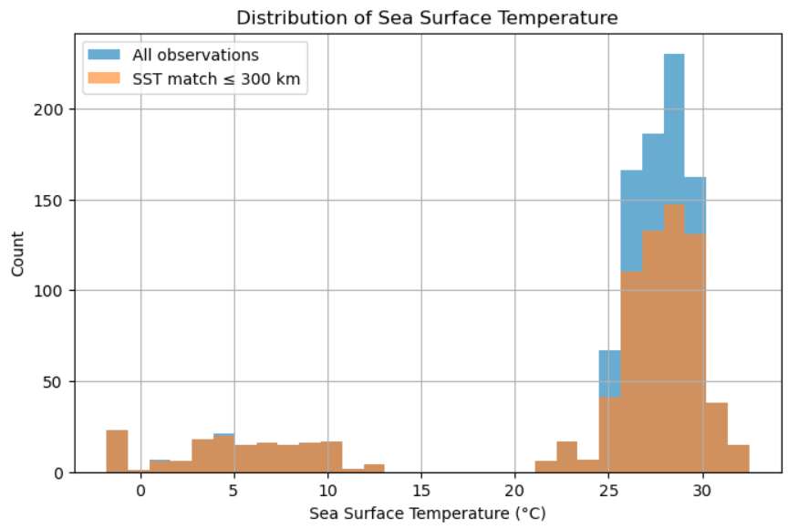
Figure A. Histogram of the distribution of SST values across all fisheries conflict events.
Since SST is a time-based variable that interferes with the two models chosen for analysis, the variable was transformed. For each event, the matched SST value was compared against the historical average SST for the same NOAA grid cell during the same calendar month. Only observations prior to the event date were used. For example, an event occurring in February 2020 was compared against the average February SST from all years preceding 2020. This prevented information from future observations from influencing historical events and produced an SST variable that represents how much warmer or cooler ocean conditions were relative to the long-term historical average at that location.
The resulting variable, sst_diff_same_month_degC, was incorporated into the predictive models alongside the existing socioeconomic and governance variables.

Integrating Southern Oscillation Index
Changes in water temperatures in the central and eastern tropical Pacific Ocean affect temperature and precipitation across the globe, impacting ability to fish, species composition and abundance of fish. The Southern Oscillation Index (SOI) tracks the atmospheric climate pattern of the el nino – la nina climate pattern by comparing the surface air pressure anomalies at Darwin, Australia to pressure anomalies at Tahiti. Positive SOI indicates a la nina while a negative SOI indicates an el nino.
Southern Oscillation Index anomaly data was obtained from NOAA Climate.gov, which had data for each month from January 1951 to June 2026. This data was then joined to the existing dataset by month and year.

Final Dataset
The final dataset included 804 conflict events that could be filtered by region, 2 continuous variables, and 14 binary variables.

Modeling Assessment and Analysis

Methods
The data was divided into training and testing subsets using a stratified train-test split. Stratification ensured that each violence category maintained approximately the same class proportions in both datasets, which prevents class imbalance from disproportionately affecting model evaluation. The data was then scaled to prevent one feature from dominating the model too heavily.
An ordinal logistic regression model with Elastic Net regularization was utilized to predict the likelihood of fisheries conflict severity given a conflict event. Elastic Net combines L1 and L2 penalties to reduce overfitting while performing feature selection.
Random Forest was trained to identify the most relevant predictors of fisheries conflict. Random Forest is a nonparametric ensemble learning method that can capture complex nonlinear relationships and interactions among variables. This is well suited for exploring whether combinations of governance, socioeconomic, environmental, and fisheries-related factors jointly influence fisheries conflict severity. traditional Gini importance can be biased toward variables with many possible split points, permutation importance was also computed. Permutation importance measures the decrease in model performance after randomly shuffling the values of each predictor. This provides a more reliable assessment of which variables the model truly depends on for prediction.
For each algorithm, hyperparameters were optimized using GridSeachCV which utilized stratified k-fold cross-validation. Candidate models were evaluated using Precision-Recall Area Under the Curve (PR-AUC), which is more appropriate than overall accuracy when class distributions are imbalanced. The best-performing parameter combination for each algorithm was then retrained using the complete training dataset before being evaluated on the independent testing dataset.
Model performance was assessed using several complementary metrics. Classification reports summarized precision, recall, and F1-score for each violence category, while confusion matrices illustrated the types of classification errors made by each model.
The analysis can be run for each region or the entire dataset. Due to the Horn of Africa having the most data available, results will focus on that region.

Model Assessment
Precision, recall, and F1-score for each violence category:
Logistic Regression with Elastic Net
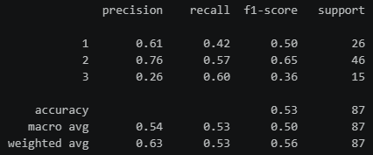
The Logistic Regression model achieved an overall accuracy of 53% on the test set. Performance varied across the three conflict severity classes, with the model struggling most to predict conflict events involving physical harm. This could be due to the lack of data with this violence_score.
Random Forest
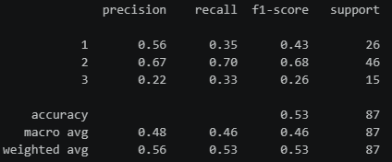
The Random Forest model achieved an overall accuracy of 53% on the test set, which shows a modest improvement over the Logistic Regression model. Again, the model struggled to predict conflict events involving physical harm.

Confusion Matrices
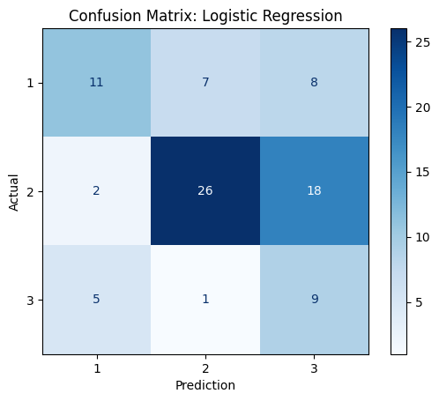
Figure B. Confusion matrix for Logistic Regression with Elastic Net for the Horn of Africa.
The confusion matrix for the Logistic Regression model shows that the model most accurately predicted moderate-intensity fishery conflicts (56% accuracy). The model had difficulty discerning between violence_score 2 and 3 and in instances where the conflict was high intensity. The model also often incorrectly assumed a low-intensity conflict when the conflict was high-intensity. This pattern indicates that many predictor variables exhibit similar values for differing level conflicts, which makes classification challenging.
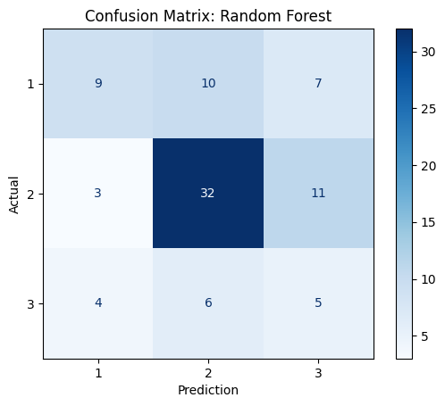
Figure C. Confusion matrix for Random Forest for the Horn of Africa.
The Random Forest model had a similar issue as the logistic regression model with inaccurately predicting high-intensity conflicts when the conflicts were medium-intensity. The high-intensity conflicts were nearly evenly distributed, showing that the model struggled to identify specific event characteristics that led to these types of fishery conflicts.
Both models exhibited similar overall predictive performance. This indicates that the primary limitation might be related to the available predictor variables rather than the choice of classification algorithm.

Model Coefficients and Odds Ratios
Logistic Regression provides interpretable coefficients that estimate the direction and magnitude of each predictor's relationship with conflict intensity. Coefficients were converted into odds ratios to facilitate interpretation. Although logistic regression allows interpretation of variable effects, its predictive performance remained moderate. This indicates that conflict intensity cannot be explained solely through linear relationships among the available predictors.
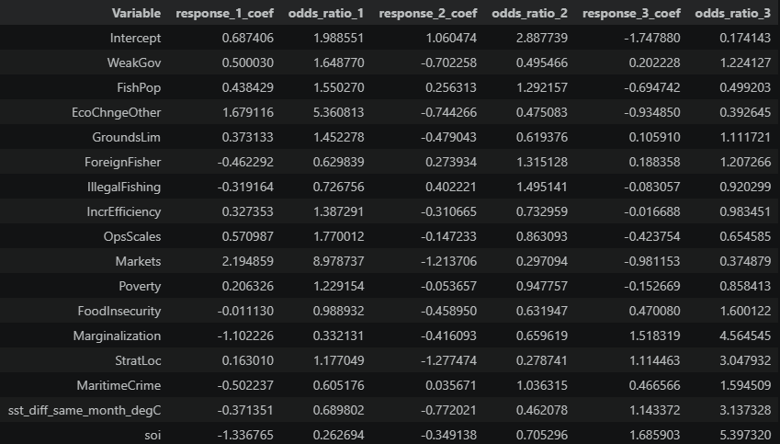Figure D. Table of Logistic Regression coefficients and odds ratios.
Figure D presents the coefficients and odds ratios from the Logistic Regression (Elastic Net) model for each violence score. Positive coefficients (odds ratio > 1) indicate that higher values of a predictor increase the likelihood of membership in each conflict severity class relative to the baseline class, while negative coefficients (odds ratio < 1) indicate a decreased likelihood.
Among the predictors, Markets (odds ratio = 2.19) and EcoChngeOther (odds ratio = 1.68) exhibited the strongest positive associations with Class 1 outcomes, which suggests that higher values of these variables increased the odds of lower-intensity fisheries conflicts relative to the reference category.
For Class 2 outcomes, IllegalFishing displayed the largest positive association (odds ratio = 0.40) followed by ForeignFisher (odds ratio = 0.27). These results suggest that illegal fishing activities and the presence of foreign fishing vessels were among the strongest contributors to predicting moderate-intensity conflicts.
For Class 3 outcomes, the largest positive associations were observed for soi (odds ratio = 1.68), Marginalization (odds ratio = 1.52), and sst_diff_same_month_degC (odds ratio = 1.14). This indicates that these variables contributed to distinguishing higher-intensity conflicts.

Shapley Additive Explanations - Feature Importance
Shapley Additive Explanations (SHAP) quantifies feature importance by calculating the marginal contribution of each variable to the model’s predictions. It calculates independent attribution values for each response type, showing how a predictor shifts probabilities toward a specific class.
EcoChngeOther, WeakGov and soi were the variables that had the highest mean absolute SHAP values. EcoChngeOther is a binary variable that indicates whether the actions of one of the parties involved in the conflict were driven by changes to the natural ecosystem, excluding health of fish populations. WeakGov is a binary variable that indicates whether the fishery conflict event involved actions driven by weak governance. Soi is a continuous variable denoting the southern oscillation index for that month and year of the conflict.
The Random Forest model found these variables to be the most relevant variables related to the fisheries conflict. Due to this, it may be beneficial to take action to decrease ecosystem changes and strengthen governance. When environmental changes do happen, it may be good to provide additional resources and/or assistance to the Horn of Africa.
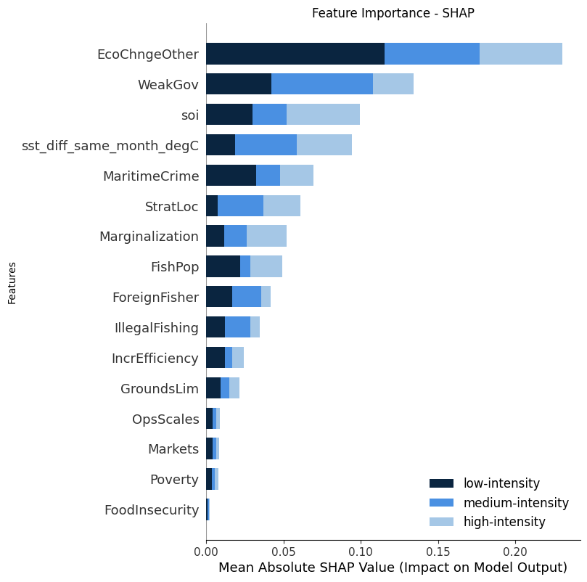
Figure E. Ranked feature importance using SHAP for each violence category.
While the confusion matrices evaluate predictive performance, the permutation

Conclusions and Future Research
Overall, both modeling approaches achieved moderate predictive performance but struggled to accurately classify high-intensity fishery conflicts. Similar performance across Logistic Regression and Random Forest suggests that the primary limitation lies not in model selection, but in the available predictors and data. Fisheries conflict is likely influenced by additional geopolitical, economic, enforcement, and environmental factors that are not fully captured within the current dataset.
While SST was added as an additional predictor, it demonstrated modest predictive value. Removing observations whose matched SST grid cell was located more than 300 km from the reported event coordinates resulted in reduced model performance. There is spatial uncertainty associated with the nearest SST grid cell at the same latitude and longitude, which remains an important limitation.
The developed modeling framework demonstrates how environmental variables from external NOAA datasets can be integrated into conflict prediction models and provides a scalable workflow that can readily incorporate other oceanographic variables for future research, such as chlorophyll concentration, wind stress, or regional climate indices.

References
GeeksforGeeks. (n.d.). Confusion matrix in machine learning. https://www.geeksforgeeks.org/machine-learning/confusion-matrix-machine-learning/
GeeksforGeeks. (n.d.). Create a correlation matrix using Python. https://www.geeksforgeeks.org/data-science/create-a-correlation-matrix-using-python/
GeeksforGeeks. (n.d.). Feature importance with random forests. https://www.geeksforgeeks.org/machine-learning/feature-importance-with-random-forests/
National Oceanic and Atmospheric Administration, Physical Sciences Laboratory. (n.d.). NOAA Extended Reconstructed Sea Surface Temperature (ERSST) Version 5. https://psl.noaa.gov/data/gridded/data.noaa.ersst.v5.html
scikit-learn developers. (n.d.). LogisticRegression. scikit-learn User Guide. https://scikit-learn.org/stable/modules/generated/sklearn.linear_model.LogisticRegression.html
Stack Overflow. (2016, September 4). Logistic regression Python solvers definitions. https://stackoverflow.com/questions/38640109/logistic-regression-python-solvers-definitions
NOAA Fisheries. (n.d.). Impacts of El Niño on Fish Distribution. https://www.pmel.noaa.gov/elnino/fish-distribution

